Practical-12

**Apache Hive**

**STEPS :**

* Login to the web console using your CloudXLab Username & password .

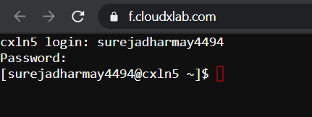

* Launch Hive by Typing hive in the Web console

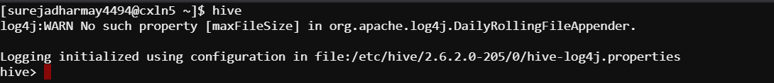

* TO see the list of all databases type command .

**show databases ;**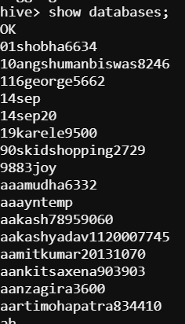

* To see the list of all tables type command .

**show tables ;**

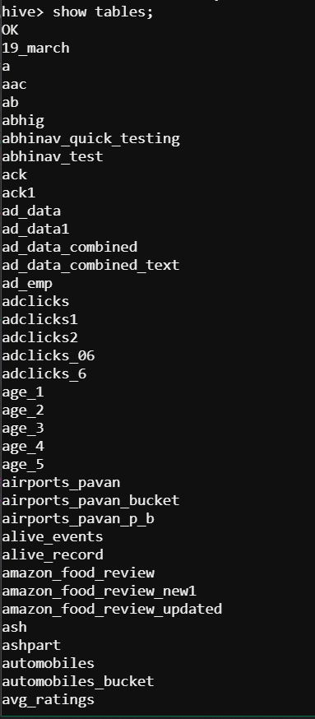

* To create your own database run below command .

${enc:USER} gets replaced by your username automatically

**create database ${env:USER} ;**

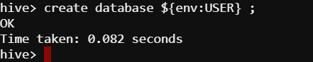

* To see metadata of your database run below commands .

${enc:USER} gets replaced by your username automatically

**describe database ${env:USER} ;**



* To use your database run below commands .

${enc:USER} gets replaced by your username automatically

**use ${env:USER} ;**

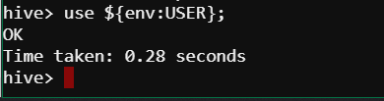

* To create a table x in your database type commands .

**create table x (a int) ;**

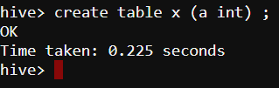

* To view the data of table x type commands .

**select * from x ;**

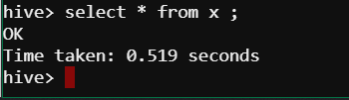

* To view the metadata(structure) of table type commands .

**describe x ;**

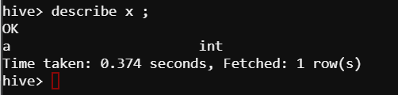

* To see the metadata and low-level details type commands .

**describe formatted x ;**

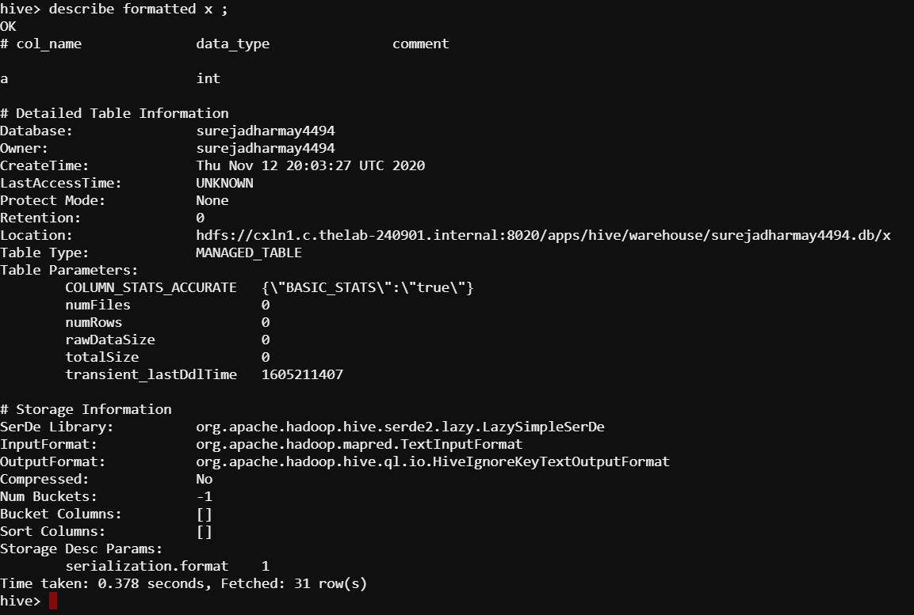

**Create a table called nyse in hive and load data from your home folder in**

**The web console**

* Login to the web console using your CloudXLab Username & password .
* Copy NYSE data from HDFS to your local.

**hadoop fs -copyToLocal /data/NYSE_daily**



* Launch Hive with typing in hive on the console. Run the below command in Hive



* Use your database by using below command .

${enc:USER} gets replaced by your username automatically

**use ${env:USER} ;**

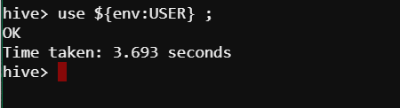

* Create table nyse using below command

**CREATE TABLE nyse(**

**exchange1 STRING,**

**symbol1 STRING,**

**ymd STRING,**

**price_open FLOAT,**

**price_high FLOAT,**

**price_low FLOAT,**

**price_close FLOAT,**

**volume INT,**

**price_adj_close FLOAT**

**)**

**ROW FORMAT DELIMITED FIELDS TERMINATED BY '\t';**

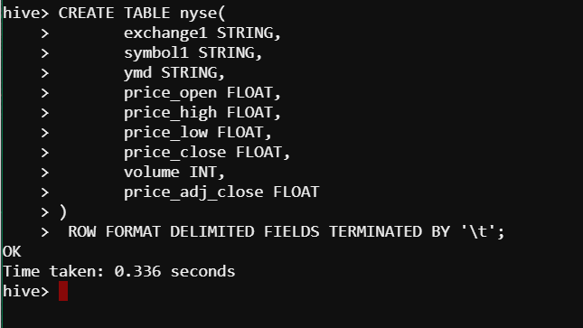

* See metadata of table using below command

**DESCRIBE nyse ;**

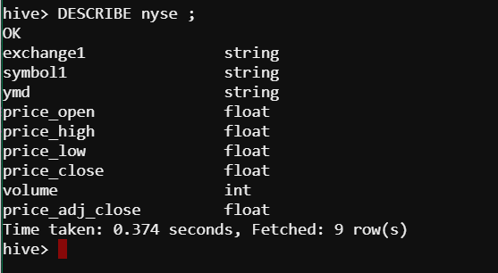

* To See more low-level details , type below command .

**DESCRIBE FORMATTED nyse ;**

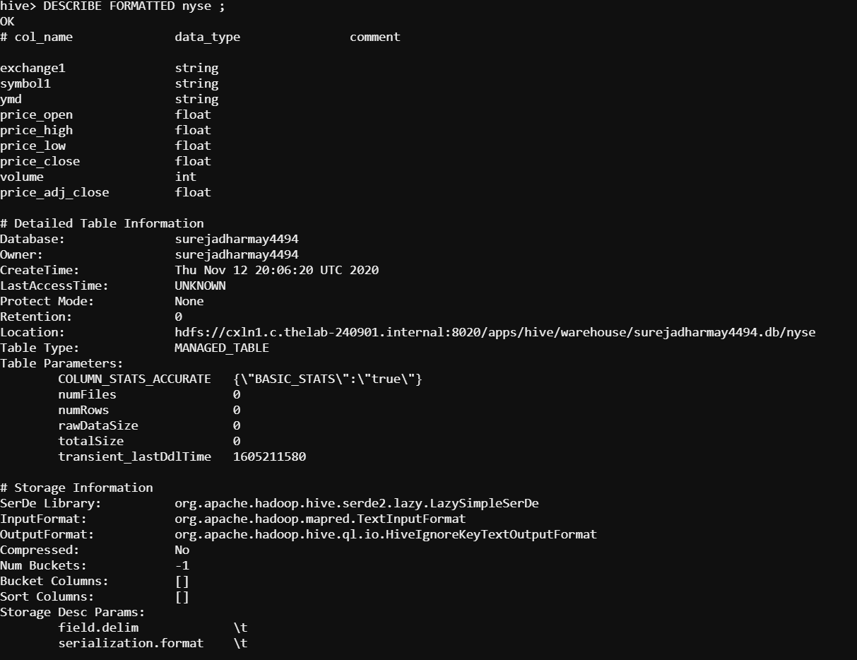

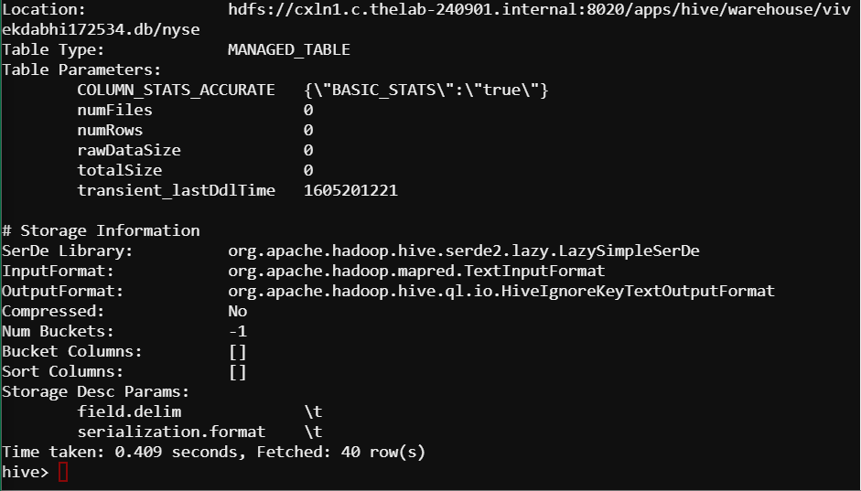

* Load data to your nyse table

**use ${env:USER} ;**

**load data local inpath ‘ NYSE_daily ’ overwrite into table nyse ;**

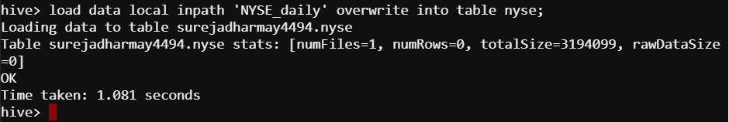

* Select rows from the table ( in HIVE console ) .

**select * from nyse ;**

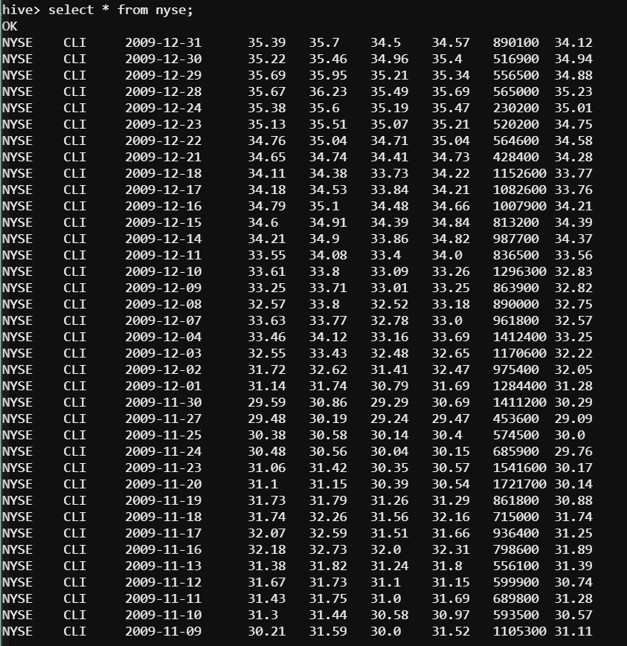

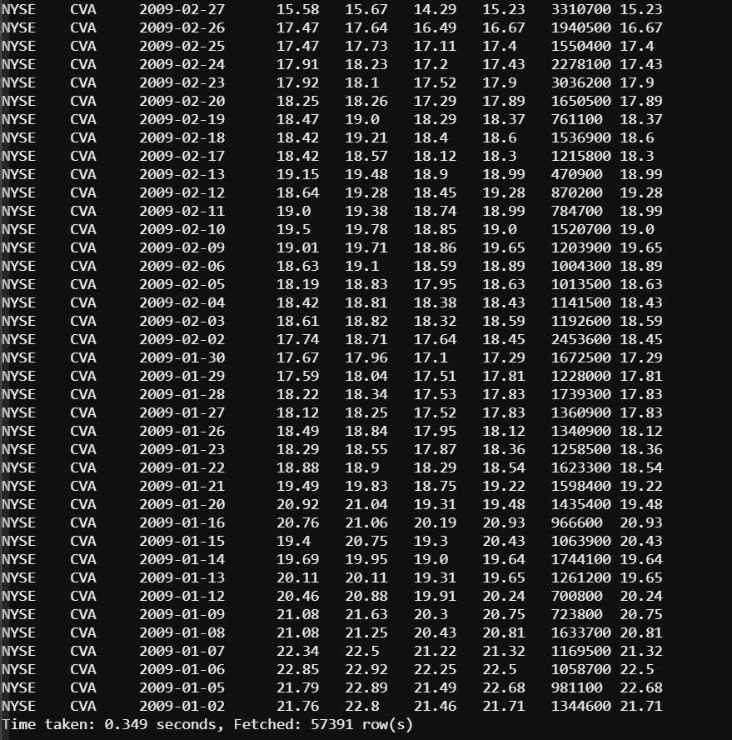

**Extra Practice :**

* Login to the web console using your CloudXLab Username & password .



* Copy NYSE data from HDFS to your local.

**hadoop fs -cp /data/NYSE_daily**



* Launch Hive with typing in hive on console .

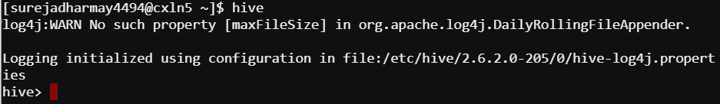

* Use your own database by using below command .

${enc:USER} gets replaced by your username automatically

**use ${env:USER} ;**



* Create table nyse using below command

**CREATE TABLE nyse_external(**

**exchange1 STRING,**

**symbol1 STRING,**

**ymd STRING,**

**price_open FLOAT,**

**price_high FLOAT,**

**price_low FLOAT,**

**price_close FLOAT,**

**volume INT,**

**price_adj_close FLOAT**

**)**

**ROW FORMAT DELIMITED FIELDS TERMINATED BY '\t';**

**LOCATION ‘/user/${env:USER}/NYSE_daily’ ;**

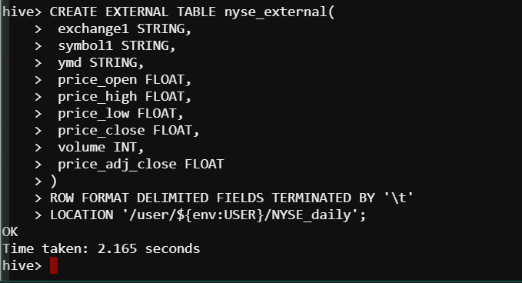

* To See more low-level details , type below command .

**DESCRIBE FORMATTED nyse_external ;**

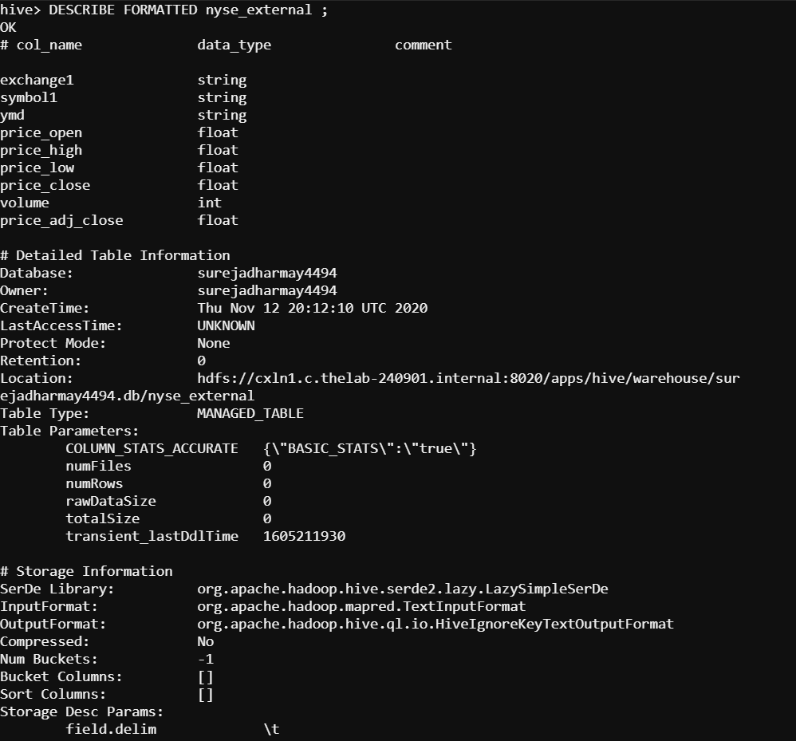

* Check the warehouse directory in HDFS by typing below command in unix console

( press ctrl+c to exit hive console ) .

**hadoop fs -ls NYSE_daily ;**



* To drop the external table type in unix console

**DROP TABLE nyse_external ;**

